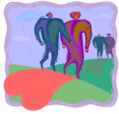
The Green Booklet no.4

Providing help from the heart

Green is the colour of HOPE

The Green Booklet directs help from the heart to others and oneself.

This means that all you think and do takes place with the intention of love.

To consistently ask yourself that what you are doing or thinking is done with love. This is important because every group that desires to survive, whether consciously or unconsciously, is in contact with others located in different areas in the world who are also experiencing difficulties.

Table of Content:

1. Introduction page 2

2. Opening the heart and strengthening the will page 3

3. Transfer love to others and self page 3

4. Suggestions to support this process and exercises page 4
5. What are Chakra’s? page 9

6. Types of disasters page 10

- Introduction

The Green Booklet focuses on offering help from the heart with love for yourself and others, where this is possible. The heart (the heart chakra) is the middle chakra of the 7 head chakra’s and forms the centre of energy for our body (refer to Chapter 5 of this booklet).

This means that all the chakra’s are connected and are fed from the heart region. These chakra’s are: the base-, sacrum-, stomach- also known as the solar plexus, heart-, throat-, forehead-, head (crown) chakra.
The love can thus flow throughout our entire being and, metaphorically speaking, “fly” outside the body to reach/touch others even at a great distance. When our actions and insight is not connected to the heart then you are dealing with short sightedness.

Science has discovered what so-called primitive people have always known, that there are invisible energetic fields through which we are connected. We do not experience this consciously. The result is that we are never separated from others; this includes our ancestors, even if this appears to be impossible. Therefore there is connection and support that keeps hope alive.
These energy fields are called all encompassing collective fields or morphogenic fields (Rupert Sheldrake). The existence of these energy fields is being proven more and more with scientific evidence.

Animals indicate by their behaviour that they can contact each other, often over great distances.

Those who open themselves to the communal consciousness’ of people who are experiencing similar survival situations will realise that what you practice in a pure form within your own group, will increase the solidarity in the collective field to survive.

When one realises this truth it will enlarge and/or widen your consciousness. One will then be more open to the fact that prayer and guided transfer of love (also over great distance) to all, both individually and collectively, will penetrate the deeper levels of consciousness.

This means that you can from heart felt love rise above suffering, and therefore play a more active role in the giving of and receiving of a wider spectrum of assistance.

The communal “we feeling” is stimulated which in turn feeds the “I-feeling” (feeling of self-worth).

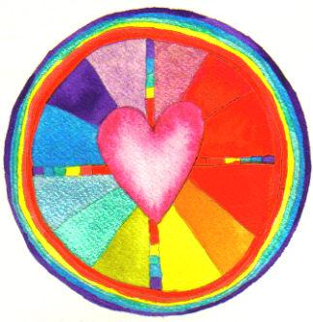

- Opening the heart and strengthening the will

When confronted with painful and fearful experiences we tend to close our heart so that we do not have to feel this unpleasantness, and prevent this from entering us. We literally build a wall around us. The situation may however be so overpowering that the wall is not high enough.

Reasons to close our heart off to feeling can be: fearful tension, pain, grief, saying goodbye to the dying and the deceased. As a result our body stiffens and we feel cold and lose our feeling of identity (who we are).

Reconnecting with our heart, however painful this may be, keeps us alive. The energy in our bodies begins to flow again. We are then able to help others in need by being distinctly closer to them, more comforting and supportive.

The only thing we can do to live in the midst of disharmony and destructive influences, that may or may not be stopped, is to strengthen our natural ability to accept to the inevitable and endure this as best we can. We need to uphold our best characteristics of our character.

- Transfer love to others and self

Try to enlarge your capacity to love and extend a positive will to the outside world to demonstrate that your heart is not easily broken. In truth, to rise above yourself.

You can be loving and powerful!

This can strengthen the feeling solidarity in the community.

To accept and give support to family, neighbours and friends is very important.

To be connected heart to heart in turn strengthens the immune system!!

The more you are centralised in your true self, the easier it becomes to build up your immunity to external negative influences (refer to The Yellow Booklet no.3;6). Try to be fully present in the here and now. We can observe with, for example, medical personnel who are hard at work yet often do not get ill due to their equitable and balanced manner in which they perform their work.

- Suggestions to support this process and exercises

- Singing together

Solidarity can be enormously increased by singing together. Inventing a song or tune together, for example. Or to tune in to the sounds that each person’s voice emits. Group singing helps people to attain a new higher consciousness level enabling them to rise above the misery.

For example, the song duo “To Be” composed and released a song concerned with facing up to the truth of a possible flood. It is a song about solidarity where nobody is excluded, and in which everyone seeks a solution including those who are not able to look after themselves due to their age and/or care needs.

(Refer to the website: www.to-be.nl; muziekformatie Carla & Paul).

Singing together is also a tremendous method to let children relax and to laugh, thus decreasing their fear.

- The use of colour (let colour do the work!)

Concentrate on the colours present in your immediate environment like the flowers or clothing that the people are wearing.
Feel what the heart tells you is a colour that makes you feel good at that moment.

You may also imagine a colour that makes you feel good.
Breath in this colour as it will strengthen you internally. Do not be bound or restricted to the meaning that people often associate with a specific colour.

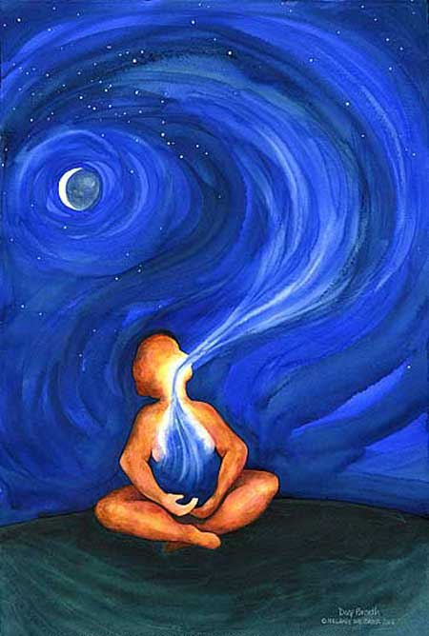
It is essential to concentrate on breathing freely and in a relaxed manner to open up the heart area
Tips:

- It is important to breath in the most free and relaxed manner possible. This means that restrictive clothing should be avoided, like a tight belt etc.

- At a physical level one should concentrate on breathing in a natural manner when confronted with a stressful situation. Breathing through the nose can be promoted by applying light prickling and stimulating remedies onto the upper lip (like Eucalyptus oil, see The Red Booklet no.1). This makes people more awake and alert. This assists to reduce psychological overburdening and too many tense thoughts playing in your head that may reduce or block an efficient breathing process. It also prevents these from attaching these negative influences in your head.

- Try to yawn frequently, this has a relaxing effect. Relax the lower jaw; letting it hang, you will naturally start to yawn. It helps to remove the tongue tip from the palate relaxing it to lie on the lower jaw. Thoughts come to rest. This also promotes more relaxed and deeper breathing.

- In crisis situations people who already suffer from a breathing problems experience an increase with this problem. Question people whether they have this problem should you expect to notice something of breathing difficulty.

- What preventative action can be taken?
Tips:
- Ensure that there is an adequate supply of medicine in the home.

People who have breathing problems and are prescribed medication will possibly have different dosages. Problems could arise should the necessary medication not be available.

Expect that tension can cause hyperventilation. To resolve this have the patient breath into a plastic or paper bag( more save for children), or have them sit with their head between their legs. This helps reduce dizziness.

It may then be useful to support the breathing process with techniques used in acupuncture and hand massage, whereby the tension in the body is reduced as quickly as possible. (Refer to the small informative booklets like the “Ankertjes” as mentioned in the list in the rear of The Red Booklet no.1;13).

- Exhale (breath out) in short bursts.

A great aid to begin regulating normal breathing again is to exhale in short bursts. Shallow breathing, before the normal and natural deep breathing rhythm resumes, will initially be followed by good hard exhalation in short bursts.
Breath like this: ksst, ksst !!, f f f f. Breath consciously with each inhalation. Follow the effect on the mid riff.

A person experiencing dyspnoea (lack of oxygen) does not tolerate shallow breathing that is pre-empted by normal breathing. In this event apply preventive exercises or another method. This is an entire technique that requires time to master and understand how it works. It cannot be quickly explained. You should experiment with this technique prior to a situation arising, which also places you in a position to evaluate whether you like and are comfortable with this technique.

- Try yawning in short bursts using your mid riff to move with the same shorts burst intensity. Try this method before you need to use it in an emergency.
- Circular movements of the trunk:

While keeping your body below the waist stationary make gentle circular movements with your upper body. Bend and stretch the trunk slowly with thrusting movements of the upper body, firstly moving upwards and then downwards. The thrusting rhythmic movement causes the chest to become more flexible thus releasing the contracted feeling in the chest as a result of inadequate breathing.

Tips continued:

- Use of specific sounds, vowels or consonants in improvised “play”.

Playing and experimenting with specific sounds, vowels and consonants can stimulate breathing and help release tension. What sounds are made is a matter of personal preference, for example: aahhh…, aa…hoemmm…).

Those who desire to master this technique can attempt to concentrate on each individual vertebrate whilst rotating the trunk in a circular motion. For those who can consciously concentrate on each individual vertebrate utilising this light circular motion, will gain more breath.

Exercises to further open the heart
Take out adequate time to perform this exercise.

- Close your eyes. Start by focussing your attention on your breath. Do not be afraid that you are doing this incorrectly or imagining that this is a specific yoga exercise. Just be aware of your breath being inhaled and exhaled.

- Concentrate your attention to the thalamus gland located under the sternum (breast bone). This gland is situated approximately four fingers width below the top of the sternum. In this manner you are concentrating energy towards the heart area, not only the physical heart but also the lungs.

- Gently breathe towards this area a couple of times. When you get the feeling that you are more aware of this region, possibly because it feels warmer; let this warmth sink in deep into the heart area and spread out throughout the chest.

- The breath can then penetrate the more deeply with each inhalation. Imagine when you exhale that you release everything that dejects you: tension, negative emotions like sadness, anger or fear.

- You will possibly feel more space and warmth enter your heart area.

- Continue this breathing and now open your eyes and if possible put on a glad face, or smile, as this helps to make you feel lighter (less dejected).

- Next, try to send positive heart energy to the outside world. Send this to all persons suffering and to all animals on earth.

- Determine how these exercises have helped you to accept and bear your own fate.

Exercise in self-encouragement

- Place your right palm gently and lovingly on your heart and left lung.

- In the same manner and at the same height place your left palm on the right lung.

- Try to focus your attention on this area warming it.

- Your heart, lungs and rib cage are completely supported by your hands, the goal being to instil peace, relaxation and encouragement.

- Your hands literally “set free” your deeper soul whereby you are able to re-experience and encourage your own true self regardless of the set back of the situation(s).

- Fill your heart with positive experiences

To fill your heart with positive experiences such as little miracles, the beauty of nature and other such beautiful experiences. A loving glance, giving and receiving a light touch from an open heart. In short, to be there for others and to seek out experiences in nature that you feel feed your soul.

(note: Respect people who wish to be left alone and who seek power and courage in their own way.)

- Carrying babies

Babies feel safe and secure when carried in a carrying bag over the heart area. Where the mothers or fathers are extremely fearful it is better to carry the child on the back. The front of a person’s body reacts more emotionally to the emotions of others (refer to The Yellow Booklet no.3;4).

- What are Chakra’s ?

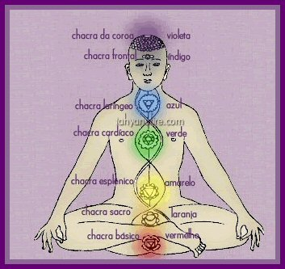

Due to the function of this Booklet only a brief explanation can be provided.

Chakra’s function as organs that absorb energy from the universal energy field. All the absorbed and transferred energy by each chakra is sent to the nearest nerve ganglion in that part of the body closest to it. This energy stream is of great importance to the proper functioning of the body’s aura field as well as the physical body (Prana or Chi, refer to The Turquoise Booklet no.5;4; and The Indigo Booklet no.6;2).

When a chakra ceases to function properly the absorption of energy will be compromised (negatively disturbed). This means that the bodily organs fed by this chakra do not receive the required energy, resulting in a weakening of the immune system leading to possible illness.
There are 7 main Chakra’s. Please refer to the above diagram. Clearly visible in the diagram is the centrally located green coloured heart chakra.

6. Types of disasters

Natural disasters

It is a difficult task to accept the unavoidable from a heart distressed with pain, sadness and fear.

Enclosed in the heart area lies the power to accept and positively submit to the situation in which you find yourself and to achieve this with an accent on a feeling of peacefulness. This enables you to focus, with an above average concentration, on what is humanly possible to help yourself and others.

For those who believe in God, Allah, and Buddha, The Universal Power (a Higher Plan of Love and Leading) the following is pertinent:

God, the Universal Source of Life, is mightier than man.
Those who believe in the Source can practise giving in to the unavoidability of the situation. Deep in their heart the godly spark is recognisable and they may also possibly know, from previous experience, that they are bound to the Creator. The situation that they need to cope with may be experienced as a test and they can endeavour to achieve active acceptance and consciously make the best of the circumstances to the advantage of themselves and their fellow human beings.

Disasters caused by human failing

To be forgiving can be difficult especially when there is gross negligence and irresponsible behaviour that has led to the disaster that has great consequences. To view the situation from the perspective of the heart, one could be more forgiving.
When you realise that you may have in the past also been less than perfect, you can more easily accept the failings of another person.

You can understand the restricted circumstances and reduce the anger to such an extent that space is created for peace which, in turn, leads to a better reaction. This may lead to the perpetrators receiving guidance that enables them to do what they are capable of. In this manner they are enabled to reduce the feeling of loss of self-worth and not feel totally isolated from their environment.

When one stands up for those who failed the possibility is created whereby they can contribute to the communal good; to make the best of the situation communally where possible.

Caused by terrorism

Once again we need to try, no matter how difficult, to control or initial anger and need for revenge. To realise from our deepest essence that we are all fallible humans, humans with the same needs and desires.

When we act from the realisation of a Higher Power of Love and Forgiveness, that we can minimise future catastrophic dramas.

What has happened has happened, and we now need to continue forwards, as we cannot turn back the clock. Retribution should be left to the Authorities e.g. The Court, but also the Higher Power who will ordain outside the realm of human observation. To correctly judge the action remains very difficult, as we are not in a position to review or have insight into all the facts leading up to the situation.

Sometimes you have to let go of situations in your heart. Time does not heal all wounds, but does make them easier to deal with. When one tries to gain insight, acceptance and digest the knowledge this offers you the opportunity to increase your chances of healing and reparation. Even when there is nothing left and you are destitute, you will have to face the future together!

