The Orange Booklet no.2

The feeling of “we”

The Dalai Lama: When you see a living creature that is dealing with suffering, then you realise that creatures are the same as us and does not want to suffer.

The Orange Booklet deals with a clear sense of togetherness. The “we” feeling in which the individual contact with each other creates a feeling of security. To encourage each other by brief interim touch, a touch on the shoulder, a pat or embrace. To often and consciously make eye contact with each other. The intention is not only to seek connection and intimacy with your loves ones, but also to extend this to the neighbourhood, village or town.

1. Introduction page 2

2. Imbalance and the ability to manage on one’s own page 3

3. Risks involved in decision-making page 3

4. Good leadership page 4

5. Epidemics page 4

6. Division of food and water page 5

7. Mutual supportive actions and exercises page 8

8. Types of disasters page 11

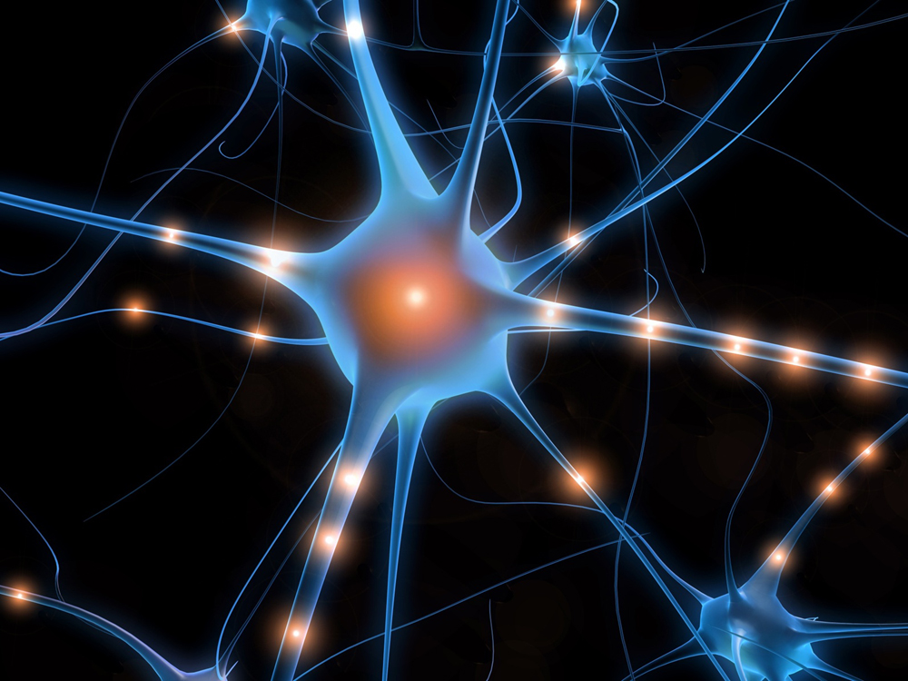

- Introduction

A feeling of togetherness, increasing the group cohesion, the formation of “cells” within the village/town.

A “cell” is a living community of people who live in the vicinity and that need one another to survive. It is important that all living and work units prepare themselves for a possible calamity concentrating on a maximised input of community will to help itself that in turn strengthens general immunity. This can reduce the negative of the results of the disaster. It is imperative to increase the cohesion of the community that do not know each other, but live in the immediate vicinity of each other. The goal is to get more involved and know what is happening in the community.

The Orange Booklet is concerned with a clear feeling and experiencing of the “we” feeling wherein in the commitment and sharing with each other creates security. Encouraging each other continually by every now and then sharing a little stroke, and pat on the shoulder, a touch of the hand or a hug, and finally to make more frequent eye contact with each other. Where one needs to vacate the area to wait for those who cannot maintain the tempo or to encourage one anther to maintain the tempo required. To carefully note how the other is coping. To regularly compliment one another for helping others and making their trip more easy or comfortable.

Allow yourself to feel and experience emotions and to share these constructively and with honesty with each other.

Those who wish to survive communally are far more reliant upon the group atmosphere than they could initially perceive. This reliance must be converted into action.

Care of adults for the children, men amongst each other, women amongst each other, couples, and family and friendship structures. The more clear and unambiguous these relationships ate structured the better they can be utilised as a network contact system.

Caring for the elderly, singles, needy for what reason, needs to be conducted in the interest of the group and planned for preventatively in an action plan. Who or which people will take care of them in addition to the care for their own immediate cell group? It may well be possible that these people are assigned extra responsibilities other than for their own group for whom they are naturally responsible.

A general overseeing coordinator needs to monitor this process from a viewpoint of attention and heart felt involvement. It becomes important to create an inventory what talents and practical and creative possibilities these persons possess so that optimal utilisation of these is made available to the group. For example, who can cook for a large party of people, who can repair items, who can care for children providing them with detractive and creative play, who has leadership qualities etc?
These conditions are better met if the community and individual neighbours get to know each other better placing them in a position to create a preventive plan in the event of a calamity. This prevents that individuals passively await what action the authorities will take and assists in the realisation that it is imperative that the community should be prepared for a possible calamity.

- Imbalance and the ability to manage on ones’ own

Individual thinking patterns are often a reflection of the greater community at large and originate from the Local Authority, the Church (or similar institution), the Government that have been developed to control the balance of power.

This has as a result that many people no longer feel themselves personally responsible and do not actively partake in planning or participation and as a result remain silent when others are not adequately dealing with power or responsibilities assigned to them or that they have taken upon themselves. This is the result of people who have too little faith in their own ability to act as an individual.

- Risks involved in decision-making

Aggressive behaviour amongst members of a social community is too often overlooked. Even when people live in the same environment they are not aware of aggressive tendencies of individuals as the social system is such that it hides these facts as this is viewed as negative or anti-social. This is also not evident in the restrictive circumstances surrounding a calamity.

People can misguidedly take control to control their own fear instead of being natural leaders. They develop a fairly aggressive leadership style and the community does not have the ability to withstand this aggressive behaviour of these individuals, this due to the non-existence of a cohesive communal feeling. This aggressive leadership behaviour originates spontaneously and impulsively with all the negative results thereof. Initially the people will trust these leaders, as they believe that they can arrange more and have a better insight of the situation than the rest. Often it becomes apparent that this initial trust is misplaced as the aggressive base of the leadership is founded in fear.

Try to avoid this situation at all cost!

- Good Leadership

A group of people finding themselves in an emergency situation have a need for good leadership
What constitutes a good leader?

- A good leader as a good insight into the situation and can take decisions with respectful consideration of the group as a whole.
- The leader must be aware of the fact that some families need more support than others. This is often the case where young children display extreme irregular behavioural symptoms due to the continuing pressure and tension to which they are subjected.
- To immediately signal dominant behavioural leadership qualities and to tactically change this into behaviour that is mutually beneficial to the group (refer to The Turquoise Booklet no.5;3).
- Helpers and/or leaders may be recognised by the look in their eyes, and can also be younger persons, thus not only adults. Those individuals can be identified by them touching others and seeking eye contact at a deeper contact level. This is the recognition of the person’s inner self that is emitted from the heart. When people recognise each other via eye contact then good work can be achieved.

- Epidemics

Prevention of fear and feelings of impotency/inability

Usually people define an epidemic as a physical ailment, such as typhoid fever. Yet a calamity like a bombardment may cause a different type of epidemic, a fear epidemic. This means that the fear epidemic can branch out and increase not only in the individual but also in the entire group becoming uncontrollable. In this case the fear must be treated in the same manner as a “normal” epidemic.

In classical homeopathy there exist certain specific remedies that are reasonably unambiguous in their application (refer to The Red Booklet for more detailed information). You may, for example, choose D30 potential to deal with the epidemic at a more primary physical and emotional level. D30 potential refers to the degree of dilution of the homeopathic remedy.

How do you deal with experiential epidemics?
- Tips:
- To reduce haste and the feeling of agitation. Taking more time to make decisions and the obtaining of sufficient rest will reduce the risk making incorrect decisions in the organisation and implementation of these decisions.

- When feelings of impotency and inability spread fast amongst members of the group, this may be identified as an epidemic. These feelings spread very quickly between the people in the group. Activation of the group will help to establish positive action and behaviour in addition to developing trust and hope.

- It is therefore important that each home-, living- and work environment is given preventative information of what to do should they be confronted with an experiential epidemic.

People are then made more aware of what they can do. How they together can achieve good decision-making, leading to the reduction the epidemic caused by the calamity.

Both at governmental level and from the aspect of complementary assistance planning needs to be implemented that is essential to enhance adequate life support systems. A tremendous amount of energy is required to achieve this and should one not be well prepared it can have a negative influence on the immune system.

To increase and maintain the immune system it is imperative that people realise that it is essential that they maintain a good emotional and physical balance! This is needed to prevent being unnecessarily susceptible to disease, illness or epidemics (natural or experiential).



6. Division of food and water

To maintain an efficient immune system it is important to eat healthy food and drink sufficient clean water.

In the event of a calamity a large shortage of healthy food and clean water may result. Destroyed crops and disrupted production and transport of food may cause this. This means that it is very important to have your own stock of food and clean drinking water as discussed in The Red Booklet no. 1;2 and 3.

In addition it is important that the community is aware of where what type of food and drinking water is available for them in their neighbourhood.

The focus of the Local Authority shifts from food safety to food availability. Yet, the Local Authority is not always in the position to organise everything for the population.

Neighbourhood watches, possibly in conjunction with the Local Authority, can inventorise where food is produced and also what type of food this is. In country districts there is more food available on farms or market gardens. In towns or cities the food supply will be decidedly less thus inhabitants must ensure a bigger supply of food and bottled water stocks.

Tips:

- Establish what food supply is available in your surroundings. Where are food manufacturers situated especially those that are essential for survival. Where are clean water depots situated?

- Local Authorities (municipalities) and private households can plant more edible food, like fruit trees and/or vegetables. These can also be grown in containers, for example fast growing and germinating vegetables (refer to The Red Booklet no.1;3).

- To share all food and water equally is very difficult where people experience hunger and/or thirst. Sharing all available food and water equally has the best long-term effect. Harmony and neighbourly love is extremely stimulating and “valuable”.

- Inventories should be made of the food and water needs of the community in the neighbourhood whereby due recognition is given to the weaker members in the group who have special needs.

- Preventative action may be found in: Transition Town Movement (see the following explanation).

- A beautiful and important initiative to follow may be found on the website “Gezonde Gronden”. (Refer to the explanation here under.)

The Transitions Town Concept (TT)
The Transitions Town Concept (TT) demonstrates how you can organise your own solutions. It requires input from your own insight(s), wisdom, creativity and experience(s) of normal people. In short: Transition Towns based on the power and knowledge present in the local community.
The TT-iniatives have as an ambitious goal the preparation of your town, neighbourhood, village or district to prepare for a combination of a permanent oil crisis (Peak Oil) and climatic crisis. The importance is thereby made to shift the economy away from dependence upon fossil fuels. This can be achieved!

www.transitiontowns.nl

Tackle the problem with head, heart and hands

Gezonde Gronden (healthy soil) makes it possible for citizens in the South West corner of the Randstad in the Netherlands to, in the near future; produce food for their city in healthy soil. (The Randstad is a large built up area in the Netherlands that includes the cities Rotterdam, The Hague and Amsterdam including all the small towns situated between these cities.)
Clean and/or healthy soil produces healthy plants and animals and ultimately healthy people. “Gezonde Gronden” entails the creation of a regional green economy involving citizens, farmers and entrepreneurs.

www.gezondegronden.nl
Gezonde Gronden connects the cities and the farm land, provides advice and instruction to:

- To produce and consume healthy food in towns and surrounding areas.
- To retain farmers in the Randstad area.
- To support farmers that wish to switch to green production on a healthy soil.
- To provide security of food provision and empower citizens to help themselves.
- To retain a Green Heart in the built-up areas for future generations.

7. Mutual supportive actions and exercises

- Back rubbing
- Massaging the coccyx
- Exercises using a soft touch
- Storytelling and/or singing together
- Name calling exercise

- Back rubbing

Where numerous persons find themselves in a tense situation whether or not one is walking to a different place, it is important to take a brief break and to rub each other’s back.

Those persons who have their back rubbed experience less tension and feel supported by their fellow companions. Rubbing each others’ back can be performed in turn and can be done by all yet costs nothing.

It may also be extremely beneficial to hum together, to hold each other and to gently rock or sway together. The tune being hummed can be whatever comes up or a tune that recalls more pleasant feelings.

b. Massaging the coccyx

You can perform this on yourself or have others do the massaging. When massaging yourself use your dominant hand balled into a fist and in firm circular movements rub over the coccyx area.
The effect is that energy that has been trapped in the lower back is released and begins to flow in the spinal column resulting in tension release.

c. Exercises with a partner utilising the touch sense to support and encourage feelings of solidarity and trust. This exercise can only be performed when at rest.

The person performing the touch, referred to as the helper, needs to make good contact with the earth. The helper will be seated whilst the patient lies down. Where the patient lies on a table the helper can either stand or sit on a chair. The helper prepares him or herself by focussing their attention inwards into themselves and from this position of strength to help the other person. Not everyone likes this type of exercise and other methods can be utilised to provide support to these people.
Determine whether or not the other person likes to be touched!

- The helper commences by holding the ankles of the patient in his/her cupped hands.

- Remain still in this position for a while.

- Thereafter alternate between massaging the feet and the toes. Literally pull the stress and tension out of the toes by individually pulling at each of them in turn.

- The helper then positions himself or herself at the head of the patient holding the base of the skull at the back of the head in his/her cupped hands.

- Give the patient time to remain lying down until it feels good to sit up.

- Both the helper and patient should drink a glass of water where this is available.

- Change positions; the helper becomes the patient and the patient the helper.

- It is important that the helper shakes off his/her hands three times after each consecutive element to shake off negative energy such as tension, tiredness, sadness, fear, and rage, of the person that you are helping to prevent this from entering the helper. Sensitive persons experience this to a greater extent.

Story telling and/or singing together

- Telling stories and singing can be done whilst resting, walking or before going to sleep.

- Both adults and children benefit from the positive effects.

- Stories and singing can both instil feelings of love, trust, hope, peace and acceptance in the here and now. They can recall positive feelings of solidarity, safety and hope while relaxing the people involved.

- For believers, of whatever faith is pertinent, singing favourite religious songs is a source of hope, trust, acceptance and love. Showing respect towards the group and your companions in distress is vitally important!

Name calling exercise
- Calling ones own name, helps to return to your own identity after experiencing a tremendous shock. This is mentioned in The Red Booklet no.1.
- To reconnect with whom you really are. To once again experience your own power making you feel more resilient.
- When all members of the group do this it enables individuals within the group to function better. You can be an authentic partner in dialogue. Should you not do this, you give others more space that they do not deserve or you take over more space in an uncontrolled manner.
Creating a well balanced and functioning community in times of crisis it is important to create the environment wherein each individual can speak from his or her own strength and expertise. Whenever an individual expresses him or herself too little or in excess, the functioning of the group is negatively affected.
- When a situation is created where people cannot function from there own “self” (Id) they project their own fears and negative feelings on others. (You say about another person what you yourself feel or experience or surmise, without checking the authenticity or truth thereof.) This can destroy a community.
- Consult for more information and exercises The Lilac Booklet no.7;8.

- Types of disasters

Natural disasters

Natural disasters have great consequences for the future.
Solidarity and unity in the community is therefore required in the community for an extended period of time. This does not go away suddenly.

Conscious realisation that the problems facing the community are to be dealt with together and that this is essential to ensure survival.

For example: When it is cold and there is not enough clothing for all, sit tightly together. Regularly change position with ach other, the people sitting inside move to the outside and those sitting outside move inward. In this manner all people can share the warmth. The disaster occurred suddenly and unexpectedly and there was no time to collect adequate clothing.

When all the available food is affected or unreachable you will have to share what is available with each other. This may be due to crop failure or that there is no transport to bring food. Where the access roads are blocked or destroyed only the combined action of the whole group/community can establish new access routes. Group cohesion is essential to achieve this. You cannot repay good with evil, but only accept what has happened with humility and create a new route or manner in which the total group/community stands to benefit.

A disaster caused by human failing

Where one or more people are suspected of willingly having caused a disaster there is a natural tendency to symbolically nail these people or persons to the wall (blame and punish them).
This drains the group energy and negatively affects the will to survive for the entire group. People are consumed by rage, vengeance, only talk about the guilty party or parties, plan revenge etc., rather than focussing on survival for all.

This results in the shifting of group integrity and this may have negative results in different areas:

  - Honest and equal sharing of the division of food is negatively affected.

  - Rendering care and assistance where needed in both the general and specific sphere is related to the holders of power and their decisions, also with a skewed result.

Power corrupts!

- Those who let themselves be seduced by an uncontrollable urge for revenge and thereby give in to destructive behaviour can no longer control themselves. We need to be consciously aware that should our behaviour be based on revenge after the occurrence of a disaster the result of this behaviour will haunt us for a long period of time.

When people demonstrate their regret shortly after the unacceptable behaviour other people are better able to understand their human failing.

It is important that social leaders who come to the fore at the moment that these person(s) displayed their human failing, positively support these people and their vulnerability and explain this human failing to the victims and other bystanders. In this manner a riot may be avoided.

Seeking solutions together regulates the angry and sad energy that has been created.

For example: When someone expresses their own vulnerability it reminds the bystanders and/or victims that they were also once vulnerable to making incorrect decisions and/or actions and that they can be thankful that they do not have to live with the, often terrible, consequences.

Disasters as a result of terrorist activity

Psychological damage is much greater where there is a terrorist related assault than in the two themes mentioned above. At the heart of this lies the feeling that the community we desire and need no longer exists. It feels as if the community has conned or cheated us. This results in the feeling that negative human failings are magnified ten fold.

Irritability is exorbitantly increased. This creates unrest as people cannot or will not wish to see the terrorist and his behaviour as one of the group or community. The terrorist is not one of us.

The possibility of being open and vulnerable towards members of the group or community are severely affected and stagnate, this when it is so important for the healing of the group or community for what has befallen them.

Explanation: Those who shun (reject) others will eventually shun (reject) themselves.

When your feelings towards the culprit are shut off, you are no longer open to others. You are then dealing only with your own anger, revulsion and sadness.

Some people wish to isolate themselves completely.

Guidance exists especially to increase the feelings of openness towards each other.

All advice that minimises the hesitance of people to help and assist each other and re-establish closeness will enormously increase the conditions wherein the affects trauma can be reduced.

Practical elements are: Lying in the arms of a loved one, uttering of comforting words, gently rocking and swaying together, to promote singing for the children, take a long look at the beauty in nature such as a flower for example. Giving in to the grandiosity of the heaven and allowing this to relax you. These are all manners in which the trauma can be repaired by what has been done to you.

The realisation that there is a Higher Will can help heal the intensity of the injustice and shock that has shattered the basis of your life.


National knowledge and advice centre
For psychological care in the event of a
Disaster

Important information!
Refer to the website:www.impact-kenniscentrum.nl
The complementary care will be additional to this organisation.

Goal

Impact has as its goal the promotion of a high quality and adequately organised psychosocial care after the occurrence of a disaster.

The tasks of Impact are to collect experiences and scientific knowledge of a disaster and to make these available to diverse target groups and to promote collusion between all concerned parties.

Advice

Impact gives advice about the content and organisation of psychosocial care after a disaster has taken place.
Impact further gives advice in a “question and answer” format in the top left on the website.
Other advice is available in a more detailed form and is discussed with the seeker in a consultation process resulting in a written advice format.

